**Course Specialist Test 3 Year 12**

Student name: ________________ Teacher name: ________________

**Task type: Response**

**Time allowed for this task: ____40_______ mins**

**Number of questions: _____7______**

**Materials required:** Calculator with CAS capability (to be provided by the student)

Standard items: Pens (blue/black preferred), pencils (including coloured), sharpener, correction fluid/tape, eraser, ruler, highlighters

Special items: Drawing instruments, templates, notes on one unfolded sheet of   
A4 paper, and up to three calculators approved for use in the WACE examinations

**Marks available: _44_____ marks**

**Task weighting: _10___%**

**Formula sheet provided: Yes**

**Note: All part questions worth more than 2 marks require working to obtain full marks.**

Q1 (6 marks) (3.3.9-3.3.10)

1. Solve the following system of linear equations. (3 marks)



1. Determine all possible values of  for the three scenarios below. (3 marks)



1. No solutions
2. One solution
3. Infinite solutions

Q2 (9 marks) (3.3.15)

A particle moves with acceleration  at time  seconds. The initial velocity is  and initial position .

1. Determine the velocity at time  seconds. (2 marks)
2. Determine the position vector at time  seconds to two decimal places. (2 marks)
3. Determine  on the cartesian path at time  seconds to two decimal places. (2 marks)
4. Determine  on the cartesian path at time  seconds to two decimal places. (3 marks)

Q3 (7 marks) (4.2.1)

Consider an artificial island that contains a revolving light that is 250 metres from shore. There is a long wall on the shore and the light from the lighthouse can be seen as a moving dot of light on the wall. The angular speed of the light is 24 radians/second, ( ).

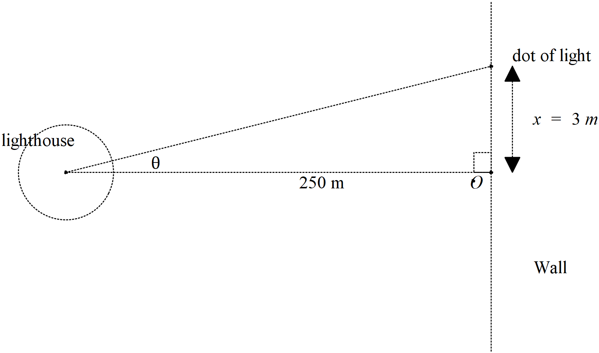

1. Determine the speed of the dot of light on the wall when the dot is 3 metres away from the closest point to the lighthouse, pt O, see diagram above. (4 marks)
2. If the artificial island containing the lighthouse is moving towards the shore, pt O, at a speed of 5 metres per second, determine the speed of the dot when 3 metres away from pt O and the lighthouse being 170 metres from the shore, pt O. (3 marks)

Q4 (3 marks) (4.1.3)

Show using logarithmic differentiation how to differentiate .

Q5 ( 8 marks) (4.1.1, 4.1.4)

Show how to evaluate the following **without any use of the classpad**. Show all working.

1.  (4 marks)

Q5 cont-

1.  (4 marks)

Q6 (7 marks) (3.3.15)

Consider a projectile that leaves with speed  at an angle  to the horizontal, see diagram. Assume that the constant acceleration is .

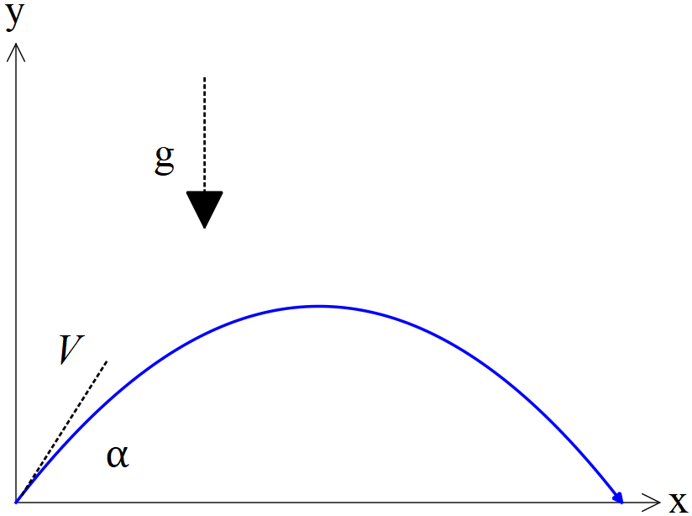

1. Using vector calculus and starting with the acceleration, show how to derive the cartesian equation of the path in terms of . (4 marks)
2. Given that  and that  when , determine possible value(s) for .

(3 marks)

Q7 (4 marks) (4.1.6)

Consider the area between ,  and the x axis with , as shown below.

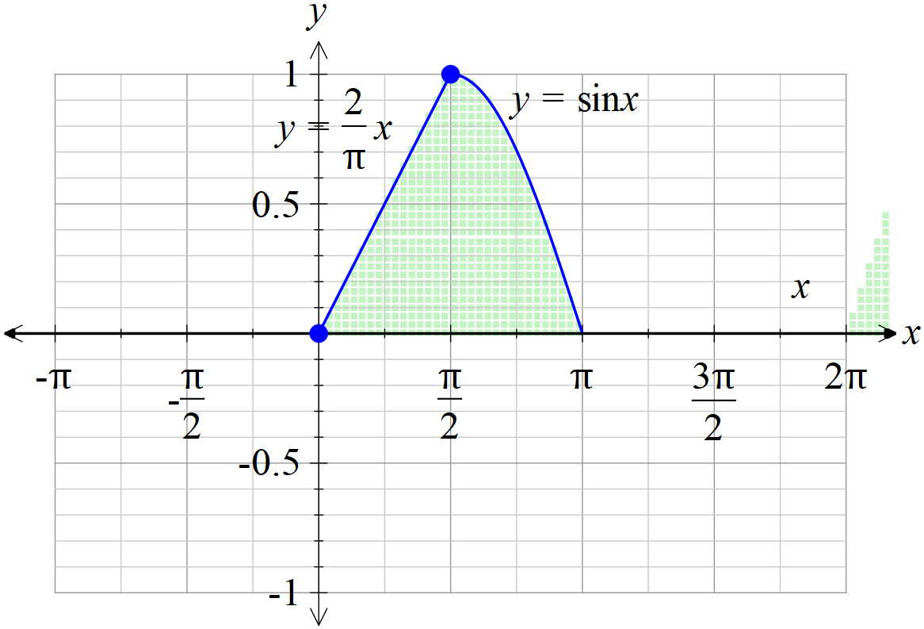

If the shaded area above is revolved **around the y axis**, determine the volume of the 3D object created to two decimal places.